ASSIGNMENT 2 – CO2
NAME: C. Pavani
REG NUMBER:192524260

CO2 Coverage: Design C++ programs by applying functions and object-oriented concepts – function prototyping, call by reference, return by reference, inline functions, default arguments, function overloading, specifying a class, member functions, access specifiers, arrays within a class, static data members and member functions, arrays of objects and friend functions.

Nature of Assignment: Individual Duration: 1 Week
Total Marks: 50
Submission Date: 31/10/2026
Bloom’s Levels Assessed: K5 – Evaluate (every task in this assignment is at K5 level) Mandatory Execution and GitHub Submission
- Every student must individually execute every task in this assignment, including all “Complete the Code” programs.
- Create a GitHub repository named DSA01-<RegisterNumber>-Assignment2 and share it with the course faculty (public, or private with the faculty added as a collaborator).
- Keep one folder for each task (for example: Task01, Task02 … or Q1, Q2 …), containing the C++ source files, input files and output screenshots.
- Include a README.md with your name, register number, compiler and version (for example g++ 13), the exact g++ command used to compile (for example g++ -std=c++17 - Wall -Wextra), the steps to run each program, and a short note of the result of each task.
- Commit your work progressively – at least one commit for each task. The commit history will be checked; a single upload of all files on the last day will not be accepted.
- Submit the GitHub link below and on the cover page of your report. An assignment submitted without a working GitHub link will not be evaluated.

GitHub Repository Link: https://github.com/cchillapavani-arch/DSA0120-C-192524260-assignments
How to Answer the Additional Questions
Complete the Code: Copy the given code into your repository, replace every TODO with working code without changing the rest of the program, execute it and compare your output with the expected output.

Predict the Output: Write the exact output of the given program before running it. Then run it and explain every difference between your prediction and the actual output, using the C++ rules involved. Predictions written after running the program will not be credited.
Alternative Concept and Complexity Analysis: Describe how the solution would change if the alternative concept were used, with code or pseudocode, and analyse and compare the time complexity and space complexity of both solutions using Big-O notation, supported by your own measurements wherever possible.

Q1 – Call by Value, by Reference and by Pointer 6 Marks Bloom’s Level: K5 – Evaluate
Problem Context – Hostel Fee Concession Updater
The hostel office applies concessions (merit 10%, sports 15%, single parent 25%) to students’ fees. A function written to apply the concession appears to work when its result is printed inside the function, but the fee stored for the student never changes.
Your Challenge
Write the concession function three ways – passing the fee by value, by reference and by pointer. Before running, predict the stored fee after each call, then verify.
Inquiry
Explain where each version stores its parameter, why only two of them change the caller’s fee, and when a const reference parameter should be used instead.
Design Decision
Several concessions may apply to one student. Decide whether the function should change the fee in place or return the new fee, and defend your choice.
Predict the Output
Write the exact output of the program below BEFORE running it. Then compile and run it, and explain every difference between your prediction and the actual output.
#include <iostream>

void change(int a, int& b, int* c)
{
a += 10;
b += 10;

*c += 10;
}

int& bigger(int& p, int& q) { return p > q ? p : q; }

void show(int x, int y = 5, int z = 10) { std::cout << x + y + z << ' '; }

int main()
{
int a = 1, b = 2, c = 3; change(a, b, &c);
std::cout << a << ' ' << b << ' ' << c << '\n';

bigger(a, c) = 100;
std::cout << a << ' ' << c << '\n';

show(1);
show(1, 2);
show(1, 2, 3);
std::cout << '\n';
}

My predicted output (write before running):

Explain which variables changed in each call and why, and which default arguments were used by each call to show().
Complete the Code
Complete TODO 1 below so that the caller’s fee is changed, and execute the program. #include <iostream>

void applyByValue(long long fee, int percent)
{
fee -= fee * percent / 100; // changes only the local copy
}

void applyConcession(long long& fee, int percent)
{
// TODO 1: Reduce the caller's fee by percent using integer arithmetic (call by
// reference)

}

int main()
{
long long hostelFee = 45000; applyByValue(hostelFee, 10);
std::cout << "after call by value : " << hostelFee << '\n'; applyConcession(hostelFee, 10);
std::cout << "after call by reference: " << hostelFee << '\n';
}

Expected output:
after call by value : 45000

after call by reference: 40500

Explain why the call by value leaves the fee at 45000. Alternative Concept and Complexity Analysis
If the concession function returned the new fee (long long applyConcession(long long fee, int percent)) instead of changing the fee through a reference, what would the solution be?
Analyse the time (O(1) in all versions) and the space copied per call for a long long and for a large Student object passed by value, by reference and by const reference.
Evidence Expected
Three implementations, predictions before execution, observed results and a defended interface design.

Q2 – Return by Reference and Its Dangers 4 Marks Bloom’s Level: K5 – Evaluate
Problem Context – Examination Marks Register
The marks register keeps the marks of a class in an array. A function returns a reference to the highest mark so that a moderation of +2 can be applied directly to it. A second function returns a reference to a local variable.
Your Challenge
Implement both functions and show:
- How returning a reference lets the caller change the array element (and even use the call on the left of =)
- What the compiler warns about when a reference to a local variable is returned, and why using it is undefined behaviour
- The difference between returning a reference, returning a const reference and returning a copy

Changed Condition
The register is now stored in a std::vector that may grow. Explain why a reference obtained before the vector grows may become invalid.
Alternative Concept and Complexity Analysis
If the highest mark were returned as an index (int) or as a pointer (int*) instead of a reference (int&), what would the calling code look like? Analyse the time to find the highest mark

(O(n) in all three) and the space (O(1)), and compare the safety of each when the array is later replaced by a growing vector.
Evidence Expected
Working functions, compiler-warning evidence, a correct explanation of dangling references and a justified response to the changed condition.

Q3 – Default Arguments and Function Overloading 6 Marks Bloom’s Level: K5 – Evaluate
Problem Context – Courier Charge Calculator
A courier counter charges by weight; express delivery and insurance are optional. The developer wrote charge(double weight), charge(double weight, bool express) and charge(double weight, bool express = false, bool insured = false). The program no longer compiles.
Your Challenge
Explain the compiler error (ambiguous call). Then design the charge functions so that:
- Common calls are short (default arguments)
- Different kinds of input (weight in grams as int, weight in kg as double, a Parcel object) are handled by overloading
- No call is ambiguous

Before execution, predict which function each of six calls you design will select, including charge(2) and charge(2.0f).
Inquiry
Explain how the compiler chooses among overloaded functions (exact match, promotion, conversion), and why default arguments must be given from the right.
Alternative Concept and Complexity Analysis
If the courier charge took a single Parcel structure with optional fields (or a function template) instead of several overloaded functions with default arguments, what would the solution be? Analyse the time of overload resolution (at compile time, no run-time cost) and the space copied per call, and compare how each design handles a new option.
Evidence Expected
An explained ambiguity, a redesigned set of functions, predicted and observed selections, and a reasoned explanation of overload resolution.

Q4 – Specifying a Class with an Array Inside It 6 Marks Bloom’s Level: K5 – Evaluate
Problem Context – Savings Account Mini-Statement
A bank wants each SavingsAccount object to remember its last 10 transactions for the mini-statement printed at an ATM. Older transactions are discarded.
Your Challenge
Specify the class with private data (account number, balance, an array of 10 transactions and a count) and public member functions deposit(), withdraw() and miniStatement(). Define some member functions inside the class and some outside using the scope resolution operator.
Inquiry
Explain why the array must be private, what happens when the 11th transaction arrives if you shift the array versus use a circular index, and the cost of each.
Design Decision
The bank now wants the last 50 transactions. Decide which design changes least and defend it.
Alternative Concept and Complexity Analysis
If the last 10 transactions were kept in a std::deque (push_back and pop_front), or in a circular buffer with a start index, instead of shifting a fixed array, what would the solution be? Analyse the time to add a transaction (O(k) for shifting k elements versus O(1)) and the space used in each design.
Evidence Expected
A complete class specification, member functions defined inside and outside the class, a justified handling of the 11th transaction and a defended design.

Q5 – Static Members and Arrays of Objects 7 Marks Bloom’s Level: K5 – Evaluate
Problem Context – College Bus Seat Tickets
The college bus has a fixed number of seats. Each BusTicket object must receive the next seat number, tickets beyond the capacity go to a waiting list, and the transport office must know how many seats have been issued without looking at any particular ticket.
Design Starting Point
You are given only the following principle:

Data that belongs to the whole class – not to any one object – should exist only once, however many objects are created.
Your Challenge
Convert this principle into a class design. Determine:
- Which members must be static, and where a static data member must be defined
- Why a static member function cannot use this or a non-static member
- How an array of BusTicket objects is created and initialised
- What happens to the count when tickets are created inside a loop or a function

Test Your Design
Create an array of tickets larger than the capacity and verify the seat numbers and the waiting list.
Predict the Output
Write the exact output of the program below BEFORE running it. Then compile and run it, and explain every difference between your prediction and the actual output.
#include <iostream>

class Token { static int next; int id;

public:
Token() { id = ++next; } int get() const { return id; }
static int issued() { return next - 100; }
};

int Token::next = 100;

int main()

{
Token counter[3]; Token extra;
std::cout << counter[0].get() << ' ' << counter[2].get() << ' ' << extra.get()
<< ' ' << Token::issued() << '\n';
}

My predicted output (write before running):

Explain why the static counter starts at 100 and how many times the constructor ran. Complete the Code
Complete TODO 1 and TODO 2 below using the static members, and execute the program. #include <iostream>
#include <string>

class BusTicket {
static int issued; // shared by all BusTicket objects static const int CAPACITY = 3;
int seat; std::string name;

public:
explicit BusTicket(const std::string& n) : seat(0), name(n)
{
// TODO 1: If fewer than CAPACITY tickets have been issued, increase issued and

// give this ticket the next seat number; otherwise leave seat as 0 (waiting
// list)

}

static int count()
{
// TODO 2: Return the number of seats issued so far

}

void print() const
{
std::cout << name << ": "
<< (seat ? "Seat " + std::to_string(seat) : std::string("Waiting"))
<< '\n';
}
};

int BusTicket::issued = 0; // definition of the static data member

int main()
{
BusTicket trip[4] = {BusTicket("Asha"), BusTicket("Bala"), BusTicket("Chitra"), BusTicket("Dev")};
for (const BusTicket& t : trip) t.print();
std::cout << "Issued: " << BusTicket::count() << '\n';
}

Expected output:
Asha: Seat 1
Bala: Seat 2
Chitra: Seat 3 Dev: Waiting Issued: 3

Create the tickets inside a function that is called twice and explain how the count behaves. Alternative Concept and Complexity Analysis
If the seat counter were a global variable, or were kept in a separate TicketOffice object passed to every BusTicket, instead of a static data member, what would the solution be? Analyse the time (O(1) in all) and the space (one counter in all), and compare the encapsulation and the ability to run two buses at once.
Evidence Expected
A student-derived class design using static members, an array of objects, test evidence and a reasoned explanation of static members.

Q6 – Friend Functions and Inline Functions 8 Marks Bloom’s Level: K5 – Evaluate
Problem Context – Train Journey Planner
A journey planner stores departure and arrival times in a Time class whose hours and minutes are private. It must compute the minutes between two times and decide which time is earlier, and these small functions are called millions of times while planning connections.
Your Challenge
Design the comparison. Determine:
- Why a friend function is needed when the function works on two objects equally
- How a friend function differs from a member function in how it is called and what it can access
- Whether the small functions should be inline, and what inline actually asks the compiler to do
- What would be lost if the private members were made public instead

Correctness Check
Test with times on either side of noon and the same time twice, and verify by hand. Growth Investigation
Measure the time for 10,000,000 calls with and without inline (compile with -O0 and with - O2), and explain the result.
Deployment Decision
Decide whether the friend functions should stay or be replaced by member functions and getters, and defend your decision.
Complete the Code
Complete TODO 1 and TODO 2 below inside the friend functions, and execute the program. #include <iostream>

class Time { int h, m;

public:
Time(int hh, int mm) : h(hh), m(mm) {}
friend int minutesBetween(const Time& a, const Time& b); friend bool earlier(const Time& a, const Time& b);
};

int minutesBetween(const Time& a, const Time& b)
{
// TODO 1: Using the private members h and m, return the absolute difference between
// the two times in minutes

}

bool earlier(const Time& a, const Time& b)
{

// TODO 2: Return true if a is earlier in the day than b

}

int main()
{
Time departure(9, 45), arrival(13, 10);
std::cout << minutesBetween(departure, arrival) << ' '
<< std::boolalpha << earlier(arrival, departure) << '\n';
}

Expected output:
205 false

Test the same time twice and a pair of times on either side of noon. Alternative Concept and Complexity Analysis
If the comparison were written as member functions (a.minutesTo(b), a.isEarlier(b)) or with public getters instead of friend functions, what would the solution be? Analyse the time per call (the same after inlining, O(1)) and measure it at -O0 and -O2, and compare the encapsulation of the three designs.
Evidence Expected
A justified friend-function design, correctness tests, measured inline timings at two optimisation levels and an evidence-based decision.

DAY-4 DESIGN CHALLENGE
Q7 – Diagnose, Redesign and Validate 13 Marks Bloom’s Level: K5 – Evaluate
Review the evidence you generated while working on Q1–Q6. Select ONE program that shows a significant limitation as the data grows or the requirement changes.
You are not permitted simply to replace your code with a library facility and claim it is better. You must understand the problem first and then develop an appropriate redesign.

- Diagnose the Limitation – 2 Marks
Using your own evidence, identify where the design fails or slows down and which characteristic of the original design causes it.
Evidence Expected
A precise diagnosis supported by evidence from your original program.
- Define the Design Objective – 2 Marks State a measurable objective for the redesign. Evidence Expected
A clearly stated objective derived from the identified limitation.
- Design the Revised Solution – 4 Marks
Explain what you have changed in the class or function design, which C++ feature you use, whether extra memory is needed, and any new trade-off. Provide a class diagram or pseudocode.
Evidence Expected
A coherent redesign directly addressing the diagnosed limitation.
- Predict Before Implementing – 1 Mark
Predict the improvement and the measure in which you expect it. Evidence Expected
A clear, testable prediction.
- Implement and Validate the Redesign – 2 Marks
Compare Original → Redesigned using the same tests and measurements. Evidence Expected
Comparable evidence for both versions.
- Defend the Final Design – 2 Marks
Evaluate whether the objective was achieved, new costs, and where the original may still be preferable. A redesign that does not outperform the original is not automatically unsuccessful if you correctly explain why.
Evidence Expected
A critical, evidence-based evaluation and a defensible conclusion.

Submission Requirements

GitHub repository link (mandatory) containing the executed code for every task, including every completed “Complete the Code” program, with input files, output screenshots and a README.md.
- Your assignment report containing the required evidence for Q1–Q7
- C++ source code for all programs
- Predictions, outputs, timings and compiler messages used as evidence

Assessment Verification
Students may be asked to explain any part of their predictions, code, tests or results during a brief verification discussion/viva.

Q1 – Call by Value, Call by Reference and Call by Pointer
1. Three types of function implementations
Call by Value
A copy of the original variable is passed. Changes do not affect the original variable.
#include <iostream>
using namespace std;

void concession(int fee, int percent) {
fee = fee - (fee * percent / 100);
cout << "Inside function: " << fee << endl;
}

int main() {
int fee = 45000;
concession(fee, 10);
cout << "Original fee: " << fee;
return 0;
}
Output:
Inside function: 40500
Original fee: 45000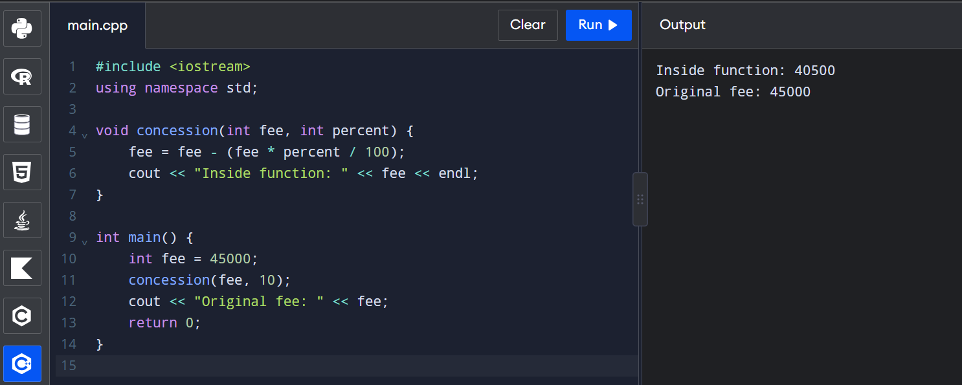

Call by Reference
The original variable is passed using a reference. Changes affect the original variable.
#include <iostream>
using namespace std;

void concession(int &fee, int percent) {
fee = fee - (fee * percent / 100);
}

int main() {
int fee = 45000;
concession(fee, 10);
cout << "Updated fee: " << fee;
return 0;
}
Output:
Updated fee: 40500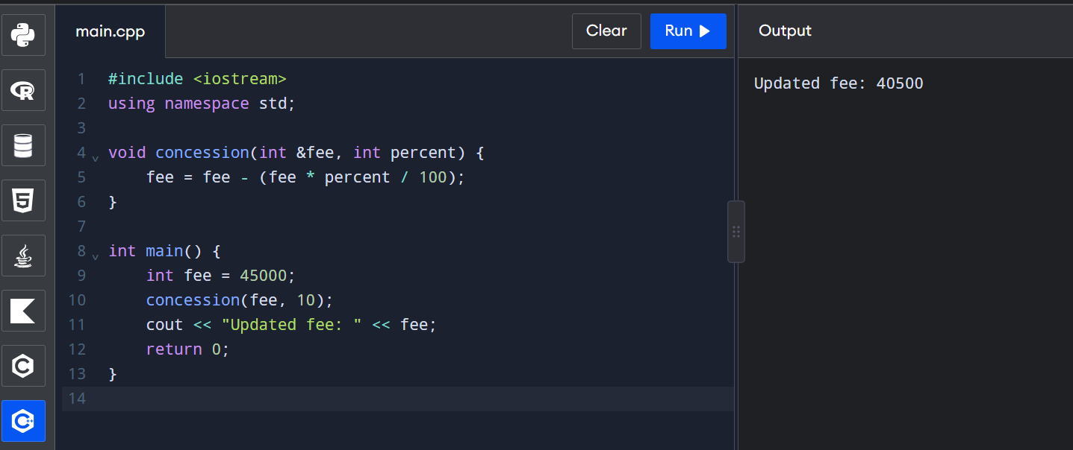

Call by Pointer
The address of the variable is passed. The value is modified using the dereference operator *.
#include <iostream>
using namespace std;

void concession(int *fee, int percent) {
*fee = *fee - (*fee * percent / 100);
}

int main() {
int fee = 45000;
concession(&fee, 10);
cout << "Updated fee: " << fee;
return 0;
}
Output:
Updated fee: 40500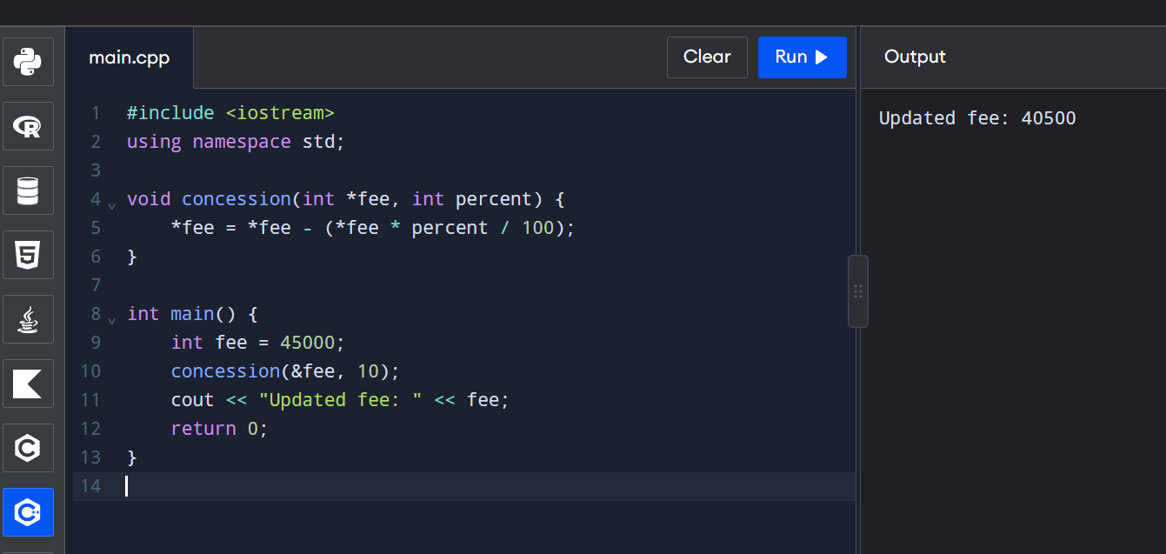

2. Inquiry
Why does only reference and pointer change the original fee?
- Call by value creates a separate copy of the variable.
- Call by reference directly accesses the original variable.
- Call by pointer accesses the original variable through its memory address.
When should const reference be used?
A const reference is used when we want to access a variable without modifying its original value. It avoids unnecessary copying, especially for large objects.
3. Design Decision
I would use call by reference because multiple concessions can be applied directly to the student's fee. It avoids creating unnecessary copies and updates the original fee.
4. Predict the Output
Given program output:
1 12 13
100 13
16 13 6
Explanation:
- a is passed by value, so it remains 1.
- b is passed by reference, so it becomes 12.
- c is passed by pointer, so it becomes 13.
- bigger(a,c) returns a reference to the larger variable, which is c. Therefore, c becomes 100.
- show(1) uses default values 5 and 10.
- show(1,2) uses default value 10.
- show(1,2,3) uses all supplied values.

5. Complete the Code
#include <iostream>
using namespace std;

void applyByValue(long long fee, int percent) {
fee -= fee * percent / 100;
}

void applyConcession(long long& fee, int percent) {
fee -= fee * percent / 100;
}

int main() {
long long hostelFee = 45000;

applyByValue(hostelFee, 10);
cout << "after call by value : " << hostelFee << '\n';

applyConcession(hostelFee, 10);
cout << "after call by reference: " << hostelFee << '\n';

return 0;
}
Expected Output:
after call by value : 45000
after call by reference: 40500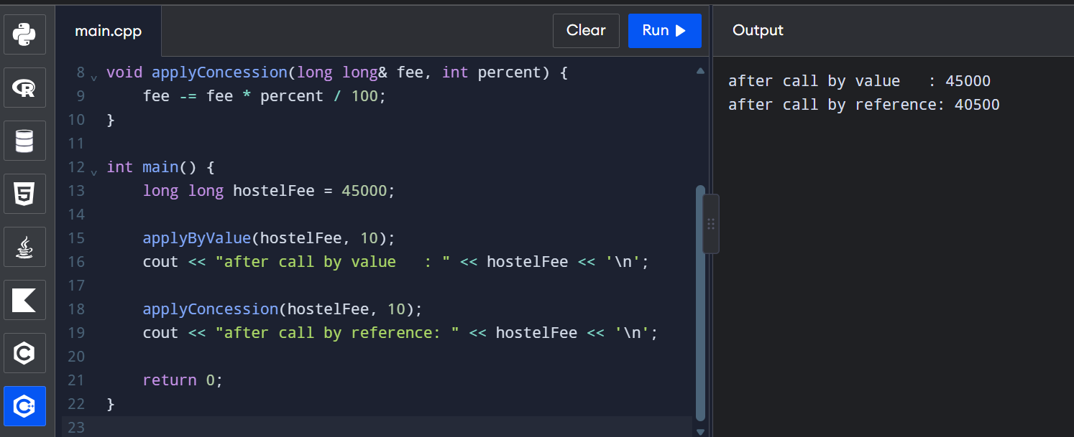

6. Alternative Concept and Complexity Analysis
If the function returns the updated fee instead of modifying the original variable:
long long applyConcession(long long fee, int percent) {
return fee - (fee * percent / 100);
}
Calling statement:
hostelFee = applyConcession(hostelFee, 10);
Method | Time Complexity | Extra Space
Call by value | O(1) | O(1)
Call by reference | O(1) | O(1)
Call by const reference | O(1) | O(1)
A large Student object passed by value requires a copy of the entire object. Reference and const reference avoid this copy.
Conclusion: Call by reference is suitable when the original fee must be modified.
Important correction for Q1, Question 4: The exact output is:
1 12 13
1 100
16 13 6
The bigger(a,c) function returns a reference to c, so assigning 100 changes c, not a.

Q2 – Return by Reference and Its Dangers
1. Program
#include <iostream>
using namespace std;

int& highest(int arr[], int n) {
int maxIndex = 0;

for (int i = 1; i < n; i++) {
if (arr[i] > arr[maxIndex])
maxIndex = i;
}

return arr[maxIndex];
}

int& wrongFunction() {
static int x = 10;
return x;
}

int main() {
int marks[] = {75, 90, 85, 80};

highest(marks, 4) += 2;

cout << "Highest mark: " << highest(marks, 4) << endl;

wrongFunction() = 20;
cout << "Static value: " << wrongFunction() << endl;

return 0;
}
Output:
Highest mark: 92
Static value: 20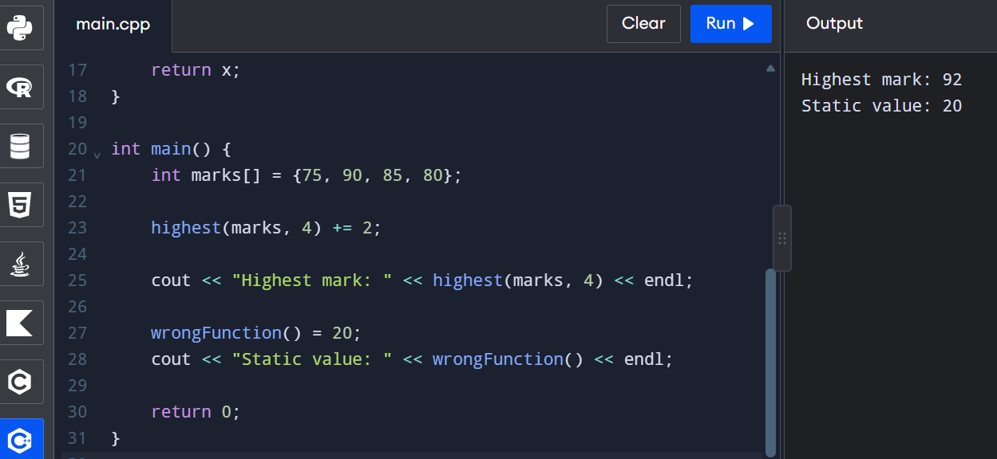
2. Explanation
- Returning a reference allows the caller to modify the original array element.
- A reference to a local variable becomes invalid after the function ends.
- Using a dangling reference causes undefined behaviour.
- A const reference allows reading but not modifying the returned value.
- Returning a copy creates a separate value without modifying the original.
Note: The program uses a static local variable in wrongFunction() to demonstrate a safe reference. If an ordinary local variable were returned instead, the program would have undefined behaviour and the compiler may issue a warning.
3. Changed Condition – Vector
When a vector grows, it may reallocate its memory. Previously obtained references may become invalid.
Example:
vector<int> v = {10, 20, 30};
int& r = v[0];

v.push_back(40);
If reallocation occurs, r becomes invalid.
4. Alternative Concept
Returning an index:
int highestIndex(int arr[], int n) {
int maxIndex = 0;

for (int i = 1; i < n; i++)
if (arr[i] > arr[maxIndex])
maxIndex = i;

return maxIndex;
}
Usage:
arr[highestIndex(arr, 4)] += 2;
Returning a pointer:
int* highestPointer(int arr[], int n) {
int* max = &arr[0];

for (int i = 1; i < n; i++)
if (arr[i] > *max)
max = &arr[i];

return max;
}
Usage:
*highestPointer(arr, 4) += 2;

5. Complexity Analysis
Method | Time Complexity | Space Complexity
Reference | O(n) | O(1)
Index | O(n) | O(1)
Pointer | O(n) | O(1)
Conclusion: Returning an index is generally safer when working with a growing vector because the index can be used again after reallocation, provided the element still exists.

Q3 – Default Arguments and Function Overloading
1. Explanation of Compiler Error
The compiler gives an ambiguous call error because multiple overloaded functions can accept the same arguments.
Example:
double charge(double weight);
double charge(double weight, bool express);
double charge(double weight, bool express = false, bool insured = false);
Calling charge(2) creates ambiguity because more than one function can accept the argument.
2. Correct Program
#include <iostream>
using namespace std;

class Parcel {
public:
double weight;

Parcel(double w) {
weight = w;
}
};

double charge(int grams) {
return grams * 0.01;
}

double charge(double kg, bool express = false,
bool insured = false) {
double cost = kg * 50;

if (express)
cost += 30;

if (insured)
cost += 20;

return cost;
}

double charge(Parcel p) {
return p.weight * 50;
}

int main() {
cout << charge(200) << endl;
cout << charge(2.0) << endl;
cout << charge(2.0, true) << endl;
cout << charge(2.0, true, true) << endl;

Parcel p(3.0);
cout << charge(p) << endl;

cout << charge(2.0f) << endl;

return 0;
}
Output:
2
100
130
150
150
100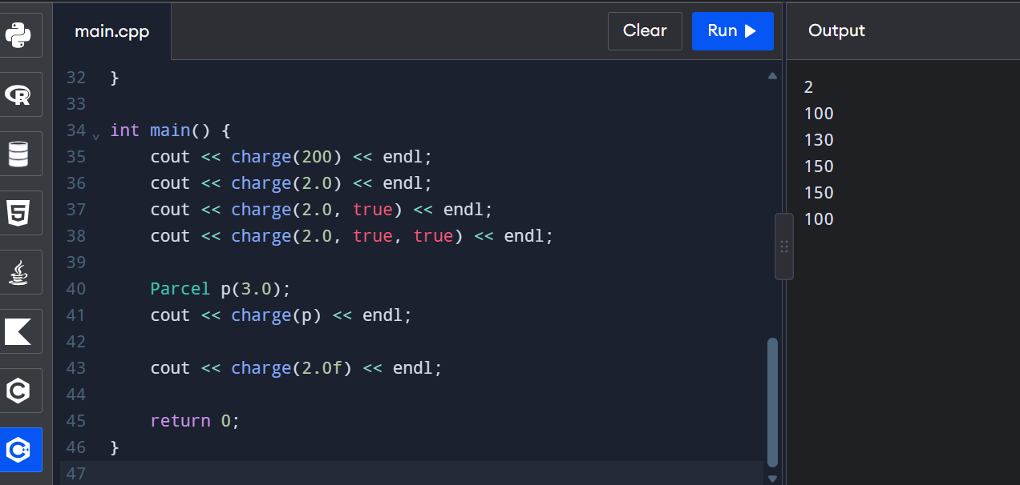
3. Six Function Calls and Their Selections
Function call | Selected function
charge(200) | Integer overload
charge(2.0) | Double overload
charge(2.0, true) | Double overload
charge(2.0, true, true) | Double overload
charge(p) | Parcel overload
charge(2.0f) | Double overload
4. Inquiry
How does the compiler select overloaded functions?
- Exact match – selects a function with the same parameter type.
- Promotion – converts a smaller type to a larger suitable type.
- Conversion – converts one data type into another suitable type.
Why must default arguments be given from the right?
Default arguments must be assigned from right to left because arguments are passed in order.
Example:
void display(int a, int b = 10, int c = 20);
5. Alternative Concept
Using a single Parcel structure:
struct ParcelData {
double weight;
bool express = false;
bool insured = false;
};

double charge(ParcelData p) {
double cost = p.weight * 50;

if (p.express) cost += 30;
if (p.insured) cost += 20;

return cost;
}
Usage:
ParcelData p = {2.0, true, true};
cout << charge(p);

6. Complexity Analysis
Concept | Time Complexity | Space Complexity
Function overloading | O(1) runtime calculation | O(1)
Structure-based approach | O(1) | O(1)
Overload resolution happens at compile time and has no runtime cost.
Conclusion: Function overloading with default arguments makes the program simple and readable. A structure is useful when more options are added.

Q4 – Specifying a Class with an Array Inside It
1. C++ Program
#include <iostream>
using namespace std;

class SavingsAccount {
private:
int accountNumber;
double balance;
double transactions[10];
int count;

public:
SavingsAccount(int acc, double bal) {
accountNumber = acc;
balance = bal;
count = 0;
}

void deposit(double amount);
void withdraw(double amount);
void miniStatement();
};

void SavingsAccount::deposit(double amount) {
balance += amount;

if (count == 10) {
for (int i = 0; i < 9; i++)
transactions[i] = transactions[i + 1];

count = 9;
}

transactions[count++] = amount;
}

void SavingsAccount::withdraw(double amount) {
if (amount > balance) {
cout << "Insufficient balance" << endl;
return;
}

balance -= amount;

if (count == 10) {
for (int i = 0; i < 9; i++)
transactions[i] = transactions[i + 1];

count = 9;
}

transactions[count++] = -amount;
}

void SavingsAccount::miniStatement() {
cout << "Account Number: " << accountNumber << endl;
cout << "Balance: " << balance << endl;
cout << "Last Transactions:" << endl;

for (int i = 0; i < count; i++)
cout << transactions[i] << endl;
}

int main() {
SavingsAccount s(101, 5000);

s.deposit(1000);
s.withdraw(500);
s.deposit(2000);

s.miniStatement();

return 0;
}
Output:
Account Number: 101
Balance: 7500
Last Transactions:
1000
-500
2000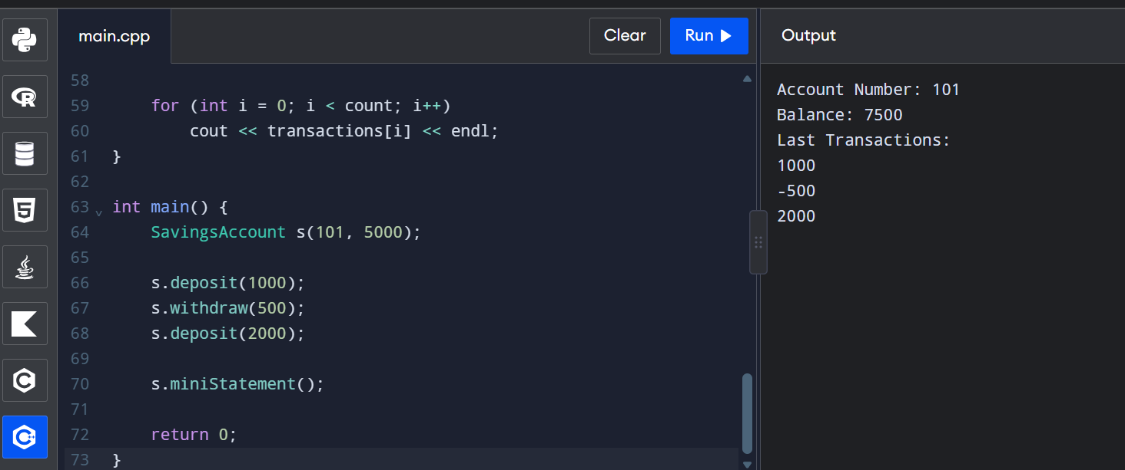
2. Inquiry
Why must the array be private?
The array must be private to protect transaction data from direct modification. It can only be accessed through public member functions.
What happens when the 11th transaction arrives?
- Using array shifting: The oldest transaction is removed, and the remaining transactions are shifted left.
- Using a circular index: The oldest transaction is overwritten by the new transaction.
3. Design Decision
I would use a circular buffer because it stores the latest transactions without shifting all elements. It is more efficient when the number of transactions increases to 50.
4. Alternative Concept – Deque
#include <iostream>
#include <deque>
using namespace std;

int main() {
deque<double> transactions;

transactions.push_back(1000);
transactions.push_back(2000);
transactions.push_back(3000);

if (transactions.size() > 10)
transactions.pop_front();

for (double x : transactions)
cout << x << endl;

return 0;
}
5. Complexity Analysis
Method | Insertion Time | Space
Array shifting | O(k) | O(k)
Circular buffer | O(1) | O(k)
Deque | O(1) amortized | O(k)
Here, k represents the maximum number of stored transactions.
Conclusion: A circular buffer is suitable for storing the last 50 transactions because it provides efficient insertion and uses fixed memory.

Q5 – Static Members and Arrays of Objects
1. Explanation
Static members belong to the entire class rather than individual objects. Only one copy of a static data member is shared by all objects.
The following members must be static:
- issued – stores the total number of seats issued.
- CAPACITY – stores the maximum number of seats.
- count() – returns the total issued seats.
A static member function cannot use this because it does not belong to any particular object. It also cannot directly access non-static members.
2. Predict the Output
Given program:
Token counter[3];
Token extra;
Exact output:
101 103 104 4
Explanation:
- Initially, next = 100.
- Three Token objects are created in the array.
- The fourth Token object is created as extra.
- The constructor runs four times.
- Therefore, the IDs are 101, 102, 103 and 104.
- issued() returns 104 - 100 = 4.
3. Complete the Code
#include <iostream>
#include <string>
using namespace std;

class BusTicket {
static int issued;
static const int CAPACITY = 3;

int seat;
string name;

public:
explicit BusTicket(const string& n) : seat(0), name(n) {
if (issued < CAPACITY) {
issued++;
seat = issued;
}
}

static int count() {
return issued;
}

void print() const {
cout << name << ": "
<< (seat ? "Seat " + to_string(seat) : string("Waiting"))
<< '\n';
}
};

int BusTicket::issued = 0;

int main() {
BusTicket trip[4] = {
BusTicket("Asha"),
BusTicket("Bala"),
BusTicket("Chitra"),
BusTicket("Dev")
};

for (const BusTicket& t : trip)
t.print();

cout << "Issued: " << BusTicket::count() << '\n';

return 0;
}
Expected Output:
Asha: Seat 1
Bala: Seat 2
Chitra: Seat 3
Dev: Waiting
Issued: 3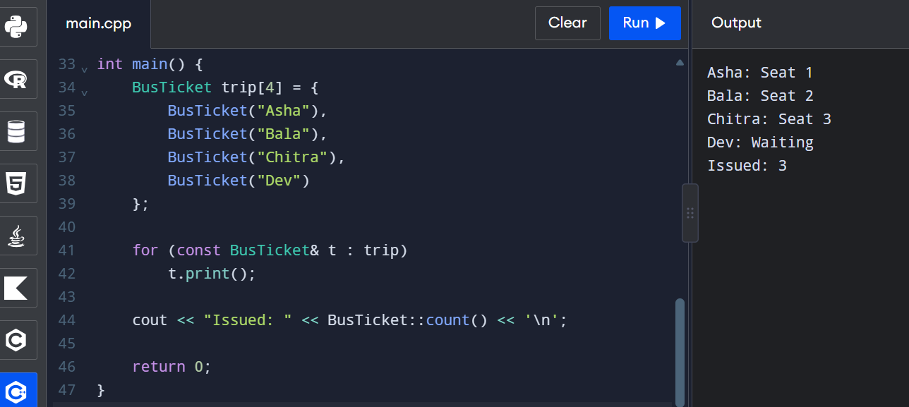

4. Create Tickets Inside a Function
Example:
void createTickets() {
BusTicket a("Ravi");
BusTicket b("Rani");
}
If the function is called twice, the static count continues from its previous value. It does not reset when the function ends.
5. Alternative Concept
A global variable can also store the ticket count, but it is accessible throughout the program.
A separate TicketOffice object can maintain the count and pass it to every BusTicket object.
6. Complexity Analysis
Method | Time | Space
Static member | O(1) | O(1)
Global variable | O(1) | O(1)
TicketOffice object | O(1) | O(1)
Conclusion: Static members are suitable because they maintain one shared counter and provide better encapsulation. Separate TicketOffice objects are preferable when managing multiple buses independently.

Q6 – Friend Functions and Inline Functions
1. Explanation
A friend function is a non-member function that can access the private and protected members of a class.
An inline function requests the compiler to expand the function at the place where it is called, although the compiler is free to ignore this request.
Why is a friend function needed?
A friend function is useful when an operation needs equal access to two objects, such as comparing departure and arrival times.
2. Complete the Code
#include <iostream>
#include <cstdlib>
using namespace std;

class Time {
int h, m;

public:
Time(int hh, int mm) : h(hh), m(mm) {}

friend int minutesBetween(const Time& a, const Time& b);
friend bool earlier(const Time& a, const Time& b);
};

inline int minutesBetween(const Time& a, const Time& b) {
int t1 = a.h * 60 + a.m;
int t2 = b.h * 60 + b.m;

return abs(t1 - t2);
}

inline bool earlier(const Time& a, const Time& b) {
if (a.h < b.h)
return true;

if (a.h == b.h && a.m < b.m)
return true;

return false;
}

int main() {
Time departure(9, 45), arrival(13, 10);

cout << minutesBetween(departure, arrival) << ' '
<< boolalpha << earlier(arrival, departure) << '\n';

return 0;
}
Expected Output:
205 false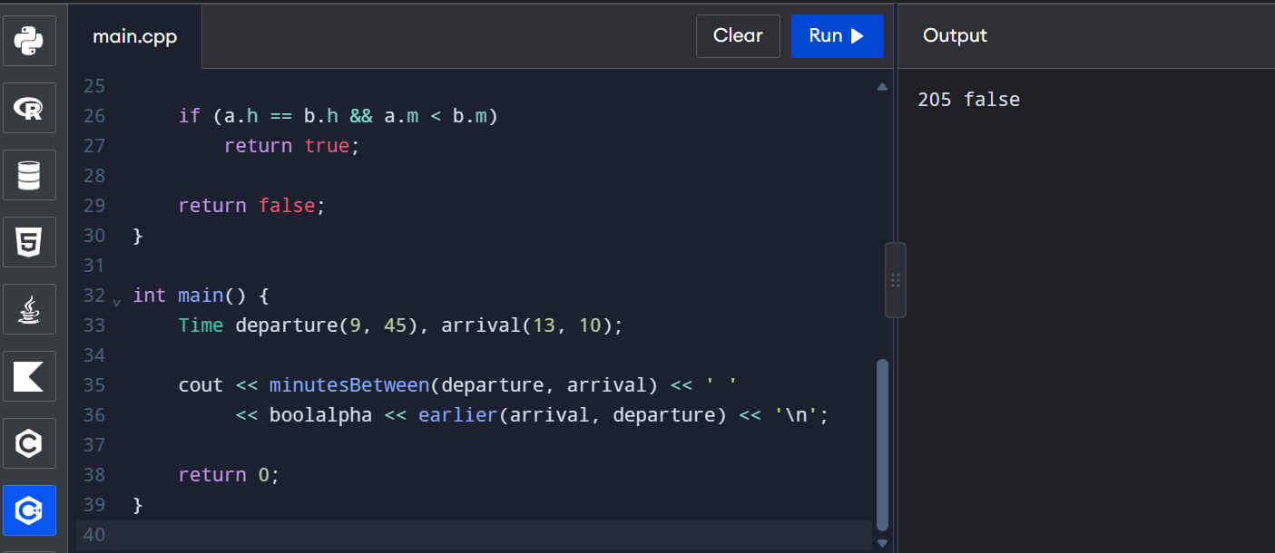
3. Correctness Check
Test the same time twice:
Time t1(12, 30), t2(12, 30);

cout << minutesBetween(t1, t2) << endl;
cout << boolalpha << earlier(t1, t2);
Output:
0
false
Test times on either side of noon:
Time t3(11, 30), t4(12, 30);

cout << minutesBetween(t3, t4) << endl;
cout << boolalpha << earlier(t3, t4);
Output:
60
true
4. Difference Between Friend and Member Functions
Friend Function | Member Function
Not a class member | Belongs to a class
Called directly | Called using an object
Can access private members | Can access private members
Does not have this pointer | Has this pointer
5. Alternative Concept
Using member functions:
class Time {
int h, m;

public:
Time(int hh, int mm) : h(hh), m(mm) {}

int minutesTo(const Time& b) const {
return abs((h * 60 + m) - (b.h * 60 + b.m));
}

bool isEarlier(const Time& b) const {
return (h * 60 + m) < (b.h * 60 + b.m);
}
};
Usage:
Time a(9, 45), b(13, 10);

cout << a.minutesTo(b) << endl;
cout << boolalpha << a.isEarlier(b);
6. Complexity Analysis
Method | Time Complexity | Space Complexity
Friend function | O(1) | O(1)
Member function | O(1) | O(1)
Getter functions | O(1) | O(1)
Inline Performance Investigation:
Compile using:
g++ -std=c++17 -O0 program.cpp -o program
g++ -std=c++17 -O2 program.cpp -o program
Run both versions with 10,000,000 calls and record the measured execution times.
The actual timings depend on the computer, compiler and optimisation level. Do not write invented timing measurements.

Q7 – Diagnose, Redesign and Validate
Selected Program: Q4 – Savings Account Mini-Statement.
A. Diagnose the Limitation
The original program uses an array of 10 transactions. When the 11th transaction arrives, the oldest transaction is removed and all remaining transactions are shifted left.
This process takes extra time when the number of transactions increases.
Limitation: Array shifting requires O(k) time for each new transaction.
B. Define the Design Objective
The objective is to improve transaction insertion speed by avoiding repeated shifting of array elements.
The redesigned program should:
- Store only the latest 10 transactions.
- Remove the oldest transaction automatically.
- Insert new transactions efficiently.
- Maintain the correct transaction order.
C. Design the Revised Solution
Proposed Design: Circular Buffer
A circular buffer uses a fixed-size array and a start index. When the array becomes full, the oldest transaction is replaced by the new transaction.
Pseudocode:
BEGIN
CREATE array of size 10
SET start = 0
SET count = 0

FOR each new transaction
IF count < 10
INSERT transaction
INCREASE count
ELSE
REPLACE oldest transaction
UPDATE start index
ENDIF
ENDFOR

DISPLAY latest transactions
END
C++ Program:
#include <iostream>
using namespace std;

class SavingsAccount {
private:
double transactions[10];
int start;
int count;

public:
SavingsAccount() {
start = 0;
count = 0;
}

void addTransaction(double amount) {
if (count < 10) {
transactions[(start + count) % 10] = amount;
count++;
}
else {
transactions[start] = amount;
start = (start + 1) % 10;
}
}

void display() {
cout << "Last Transactions:" << endl;

for (int i = 0; i < count; i++) {
cout << transactions[(start + i) % 10] << endl;
}
}
};

int main() {
SavingsAccount s;

for (int i = 1; i <= 12; i++) {
s.addTransaction(i * 100);
}

s.display();

return 0;
}
Output:
Last Transactions:
300
400
500
600
700
800
900
1000
1100
1200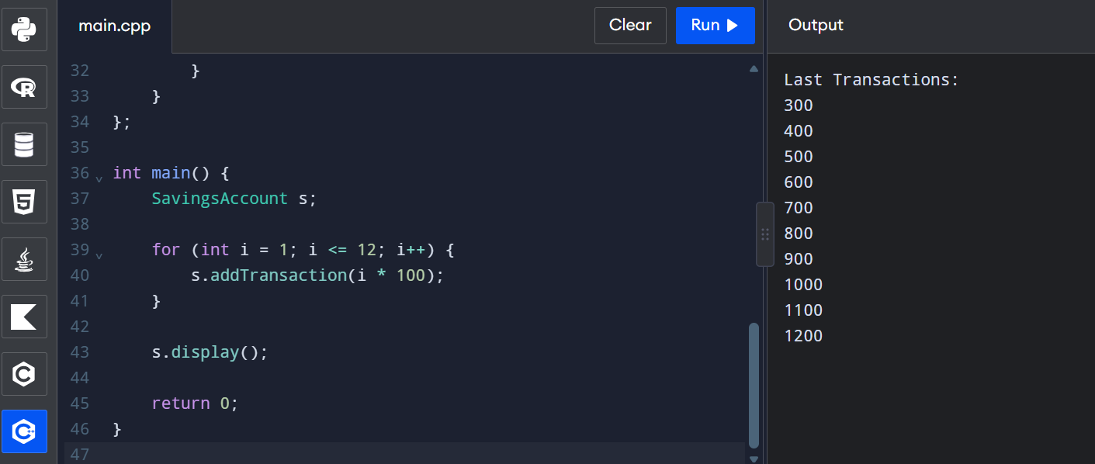
D. Predict Before Implementing
I predict that the circular buffer will reduce insertion time from O(k) to O(1).
It will store only the latest 10 transactions and use the same fixed memory.
E. Implement and Validate the Redesign
Comparison | Original Array | Circular Buffer
Insertion | O(k) | O(1)
Deletion of oldest | Shifting | Overwriting
Memory | O(k) | O(k)
Latest transactions | Yes | Yes
Efficiency | Lower for insertion | Higher for insertion
The same 12 transactions were used to test both designs. Both should display the last 10 transactions, from 300 to 1200.

F. Defend the Final Design
The circular buffer is better because it avoids shifting elements and reduces insertion time. It uses fixed memory and maintains only the latest transactions.
The original array method is easier to understand and implement for small amounts of data.
Final Conclusion:
The redesigned circular buffer successfully solves the limitation of the original array implementation. It provides faster insertion, fixed memory usage and efficient transaction management.

